RULE60V3-6095 Tri-mode (QMK+VIA) Product Function Specification

## 1.layout：

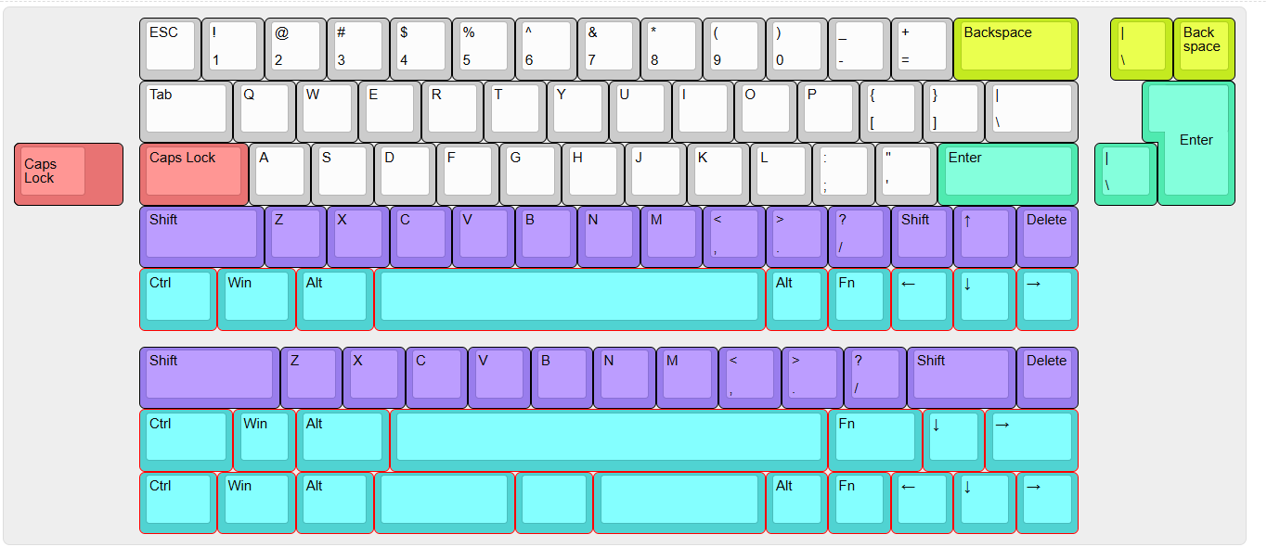

Layout support：

Normal GH60, supports 6.25U space, split space (2.25+1.25+2.75), 7U space, ANSI enter, ISO enter, stepped CAPSLOCK, split backspace.

2.function

1.nkro, via/qmk supported

Via compatible in wired mode only

2.Indicator lights 1) CAPSLOCK, switch to uppercase and the light turns red, mode status indication (win/mac/three-mode switch/Bluetooth switch). 2) Charging indicator light, when the keyboard enters the charging state, the uppercase and lowercase indicator lights up red for 5 seconds and then turns off.

3.tri mode

1、wired

Nkro, 1000hz polling rate

## 2、wireless

|  |  |  |
| --- | --- | --- |
|  | bluetooth | 2.4G |
| version | 5.0及以上 | - |
| Polling rate | 125Hz | 1KHz |
| First delay |  |  |
| Second delay |  |  |
| Third delay | 22~22ms（default） | 8~10ms（default） |
| Sleep mode | It will enter shallow sleep after 30 minutes of non-use, and can be awakened by pressing any key without swallowing the first word;  It will enter deep sleep after 2 hours of non-use, and can be awakened by pressing any key, and the awakening time is less than 30ms。 | |
| other | nkro | |

## 3、mode switch

2-stage switch, just switch the power on and off (the reverse side is a SMD wave switch, the switch is on the left border of the left shift key)

4.logic

## 1、wired mode：

## Plug in the Type-C port, press FN+B to switch to wired mode, and the uppercase and lowercase red lights flash 3 times.

## 2、2.4G mode：

If you need to re-pair the receiver, long press the FN+V key combination, the indicator light flashes yellow quickly (3 times/second) to search for the receiver, and after successful connection, it will light up yellow for 3 seconds and then go out. If the paired receiver cannot be found after 60 seconds, exit the pairing code, the keyboard reconnection time is 20 seconds, the indicator light flashes yellow slowly, the indicator light goes out if the reconnection fails, and the keyboard goes to sleep. After successful reconnection, the indicator light stays yellow for 3 seconds and then goes out, and the keyboard goes to sleep after 10 minutes if it is not in use.

3、bluetooth mode：The Bluetooth connection key combination is ZXC. Press FN+ZXC for 3 seconds to broadcast, and short press separately to switch Bluetooth devices. After pressing the key combination for 3S to enter the pairing state, the indicator light (corresponding to the Bluetooth device ZXC blue) flashes quickly (3 times/second). After the pairing is successful, the indicator light stays on for 3 seconds and then goes out. After 60 seconds of not finding the paired device, the pairing is exited and the indicator light goes out. The keyboard reconnection time is 20 seconds. The indicator light flashes slowly. The indicator light goes out if the reconnection fails, and the keyboard goes to sleep. After the keyboard reconnects successfully, the indicator light stays on for 3 seconds and then goes out. If the keyboard is not in use, it goes into sleep after 10 minutes.

The corresponding colors of Bluetooth devices 123 are as follows: Bluetooth Z-red light corresponds to Bluetooth name: 6095ble-1 Bluetooth X-red light corresponds to Bluetooth name: 6095ble-2 Bluetooth C-red light corresponds to Bluetooth name: 6095ble-3

1. FN function keys

1. Press and hold Fn+Backspace for 3 seconds, the keyboard will be restored to factory settings, and the indicator light will flash red-green-blue 3 times.

2. Fn+M to switch Win/MAC system,

Switch to Win system, the CAPSLOCK key will flash blue 3 times, switch to Mac system, the white light will flash 3 times

3. Fn+win to lock the win key

4. Fn+"1~=" is "F1-F12", Fn+Esc=`, Fn+Shift+Esc=~

5. Fn+Z/X/C/V/B to switch to three modes (directly use FN+Z/X/C/V/B to switch 2.4G/BT1/BT2/BT3/wired mode.a.FN+Z---short press to switch to Bluetooth device 1, long press 3S to enter pairing.

b.FN+X---short press to switch to Bluetooth Device 2, long press 3S to enter pairing.

c. FN+C---short press to switch to Bluetooth device 3, long press 3S to enter pairing.

d. FN+V---short press to switch to 2.4g mode, long press 3S to enter 2.4G pairing receiver mode.

e. FN+B---short press to switch to wired mode.

6. Low voltage mode: Without USB plugged in, when the power is equal to or less than 20%, the indicator key will flash green slowly to remind the user to charge. (Note: When the battery voltage is lower than 5%, the keyboard will stop working directly. At this time, when the key is pressed, the keyboard will flash as a whole to prompt, and there will be no response. It reminds customers to plug in the USB cable and charge to more than 5% before waking up to work normally)

1. FN function keys light mode

Lighting effect: QMK/VIA default lighting effect

1. FN+Q turns off/on the key lighting

2. FN+W previous lighting effect

3. FN+E next lighting effect

4. FN+R speeds up the lighting

5. FN+T slows down the lighting

6. FN+A increases the brightness of the lighting

7. FN+S decreases the brightness of the lighting

1. keymap

1、default：



2.FN layer

